Travel planner

Cpcs 403

Abdulaziz Alghamdi 2035244

Bandar Habib 2036359

Contents

Project idea 2

Recommended solution 2

Benefits 3

Storyboard 4

Site map 8

**Table of Figures**

Figure 1: Home page 4

Figure 2: Create Plan 5

Figure 3: Our project 6

Figure 4: Contact 7

Figure 5: Site map 8

# Project idea

The objective of this project is to design a smart AI model that can provide travel planning, especially in our great land Saudi Arabia by taking travelers' personalized recommendations and assisting them. Also, we will create our model from basic knowledge, and we aim to revolutionize the way travelers plan their trips to Saudi Arabia by applying the methods of artificial intelligence.

The main issue is to develop a model that can understand user preferences and analyze travel-related data mainly for Saudi Arabia. To improve the quality of travel within Saudi Arabia, we also need to produce suggestions for local attractions and highlight the top hotels and activities based on the user's tastes, budget, and available transportation. By applying machine learning and other AI methodologies, the model will help users make their decisions by providing travel plans in Saudi lands that are made especially for every traveler's specific preference.

# Recommended solution

To implement our project idea, we first need a website to act as a link between the traveler and the AI model. Site where the traveler can enter his preferences such as where he wants to go, what his maximum budget is, and many other preferences. So, our model will take the preferences, analyze them on the backend, and create plans that meet your preferences.

**Intelligent Plan Recommendations:** Our AI model considers user-defined criteria, such as budget constraints and desired destinations, to generate tailored travel plans. Our model examines large amounts of available travel data on accommodations, as well as sights and sites to be seen. It generates an optimized set of itineraries that match the user’s preferences and restrictions. The AI model constantly learns and adjusts based on feedback from users as well as market/trend trends to keep recommendations current.

# Benefits

Easier travel planning for travelers that are willing to come to Saudi Arabia and explore the wonderful cities like, the capital Riyadh where the modern high towers and the businesses are located or going to Jeddah the Bride of the Red Sea, that has one of the best diving places in the world. Now, travelers can plan their trip without worrying about how much it will cost and how much it will take time to create a plan.

**Cost and Time Efficiency:** By utilizing AI algorithms, our solution optimizes travel plans to minimize costs while maximizing the value of the experience. The model considers various factors such as hotel rates, and local transportation options to find the most cost-effective options for each user's unique requirements. Additionally, the AI planner optimizes the itinerary's time allocation, ensuring efficient utilization of available days, and suggesting the best routes and schedules.

**Independence from Travel Agencies:** With our AI-powered solution, users no longer need to rely on travel agencies to plan their trips. By providing comprehensive and reliable travel recommendations, our model empowers individuals to plan their own trips with confidence, eliminating the need for intermediaries.

# Storyboard

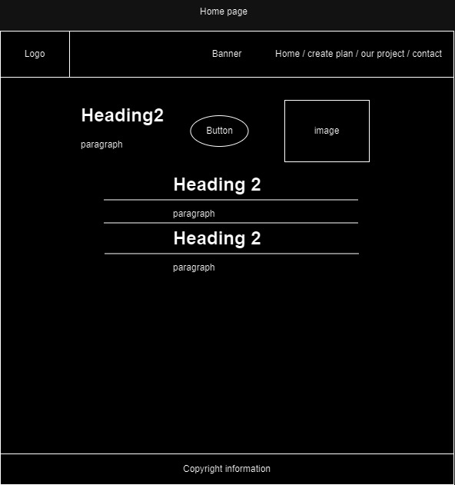

Figure : Home page

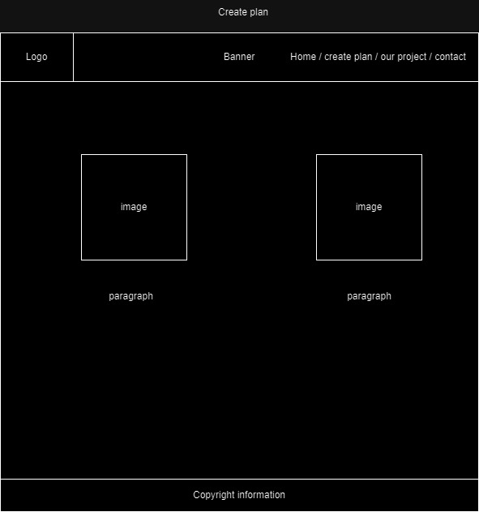

Figure : Create Plan

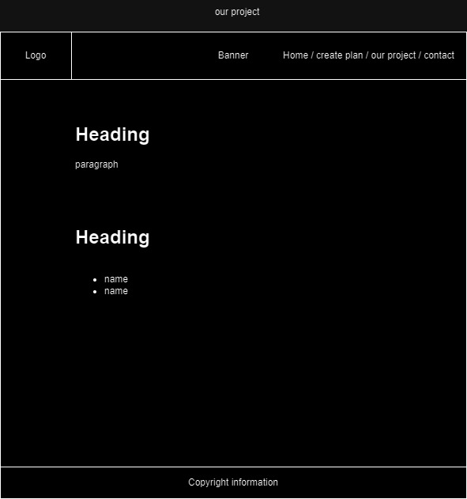

Figure : Our project

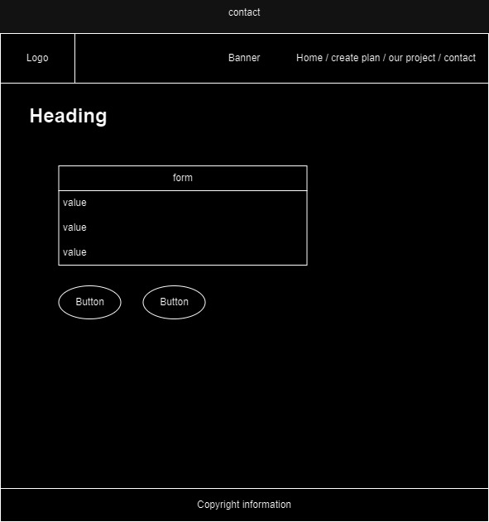

Figure : Contact

# Site map

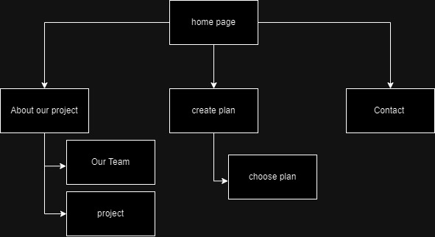

Figure : Site map